**Name : Gowtham S**

**Batch : 1**

1. select * from Customer;

create table loan (loanid int primary key,amount money ,custid int,Emi money);

insert into loan values(1000, 50000,100,50000)

insert into loan values(1001, 40000,101,90000)

insert into loan values(1002,25000,102,7000)

insert into loan values(1003, 14000,103,14000)

insert into loan values(1004,150000,104,60000)

select Loanid, Emi from loan where emi>50000;

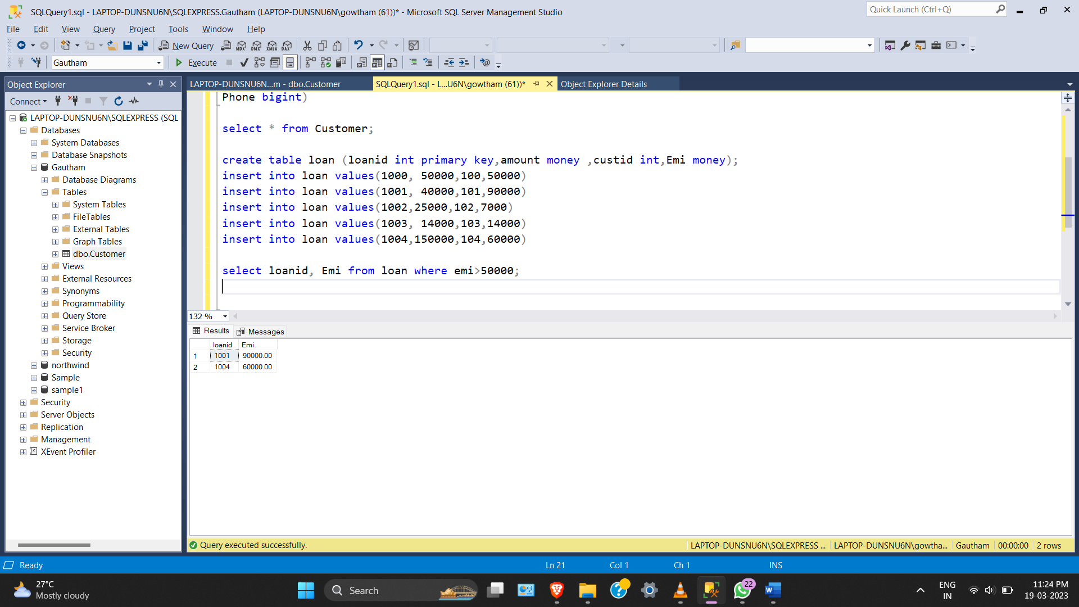

2) select emi,count(loanid)'No Of Loan' from loan group by amount,emi;

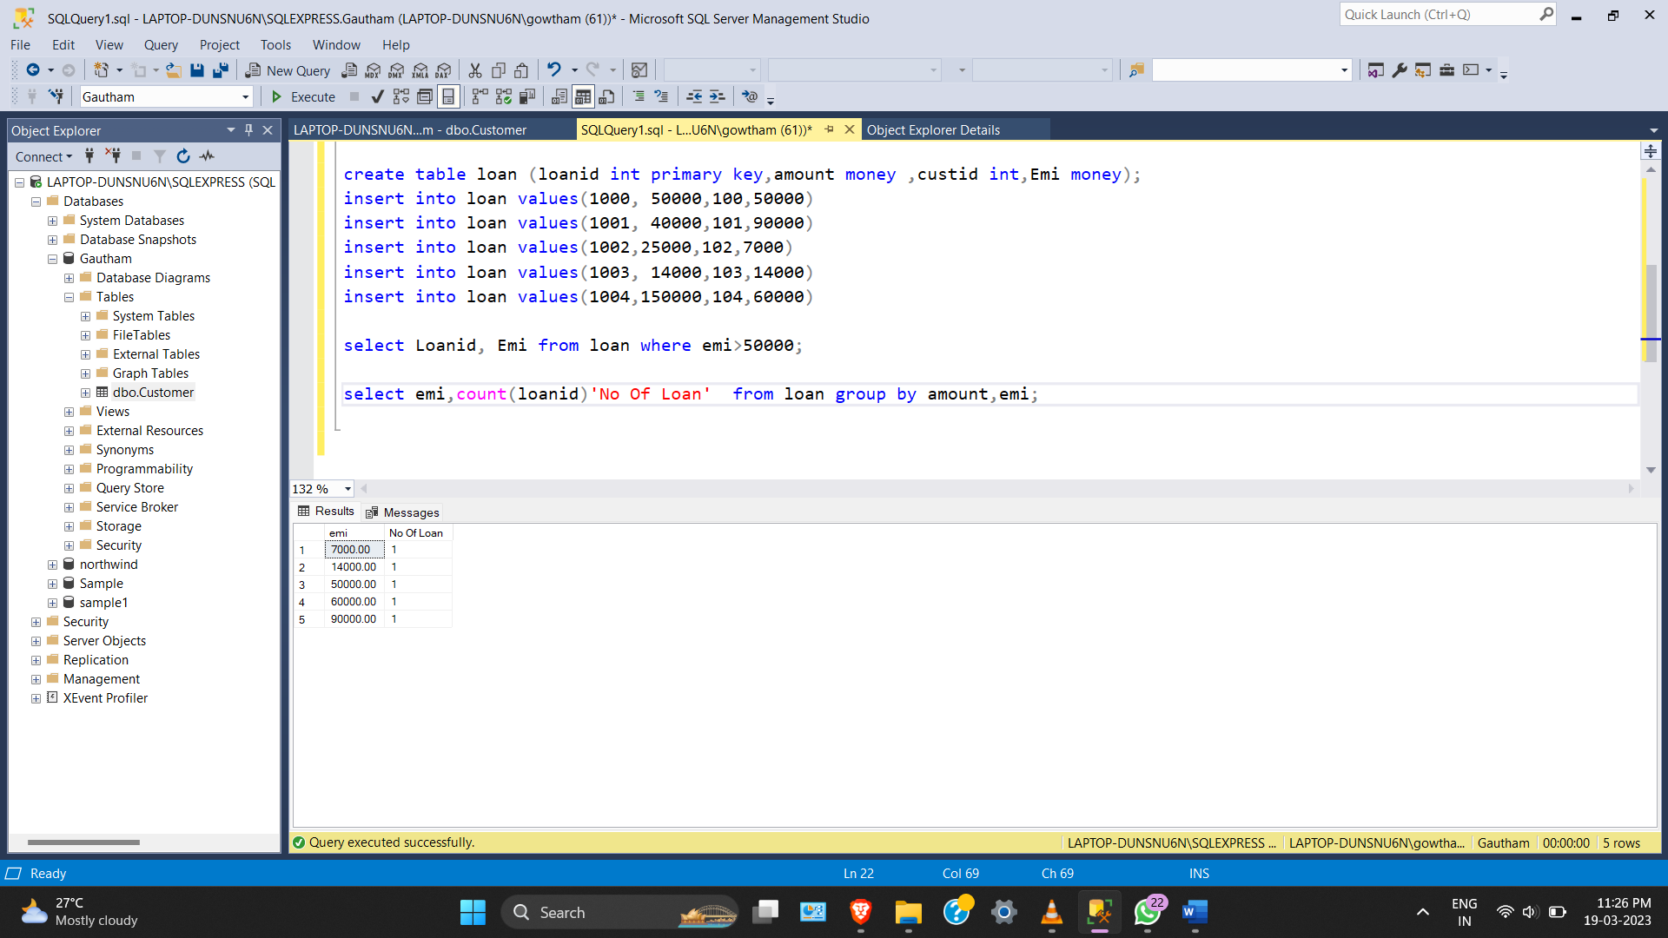

3) CREATE VIEW view_1 AS

select * from loan

SELECT count(loanid) 'Total no of loans'

FROM view_1;

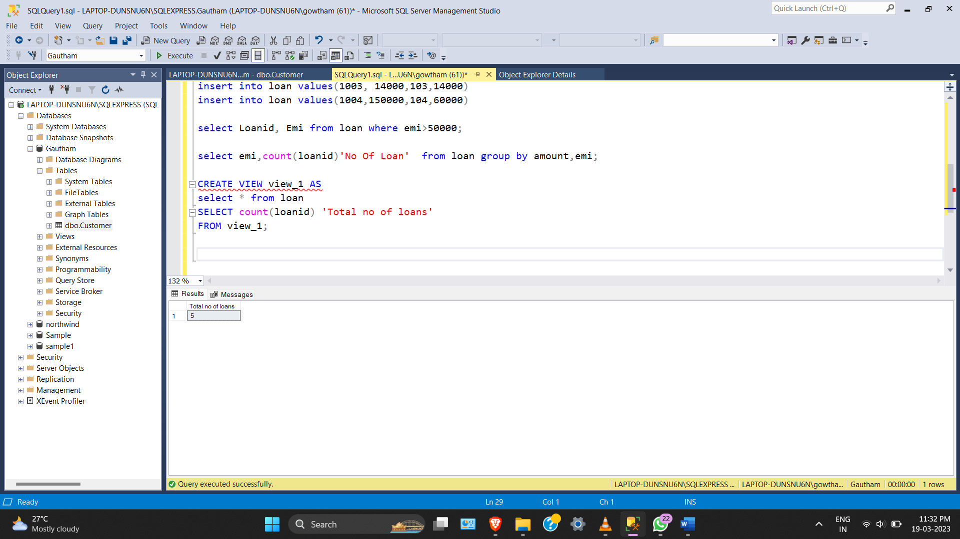

4) select * from loan

select * from Customer

select emi from loan where custid =

(select cusid from Customer where Custname = 'smith')

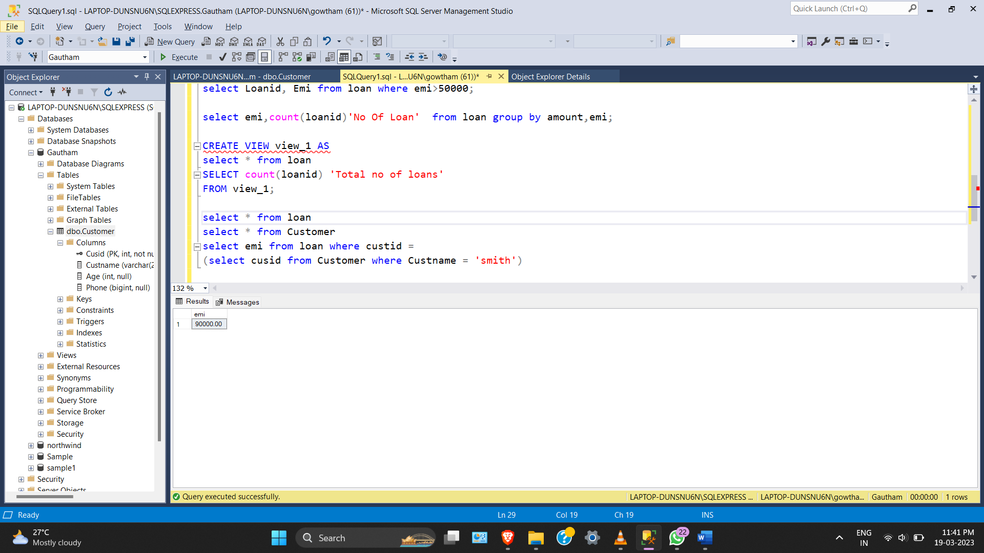

5) create or alter procedure sample1(@loanID int)

as

begin

declare @amount varchar(20),

@custid varchar(20)

set @amount=(select amount from loan where loanid=@loanID)

set @custid =(select custid from loan where loanid=@loanID)

print 'CustomerId '+(convert (varchar(20),@custid))

print 'Amount '+@amount

end

sample1 '1001'

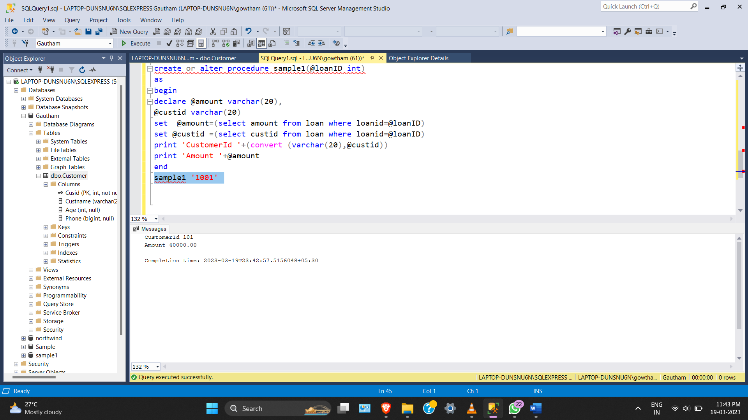

6) create or alter function samplefunc(@custid int)

returns money

begin

declare @amount money

set @amount=(select amount from loan where custid=@custid)

return @amount

end

select dbo.samplefunc(100)'Amount'

